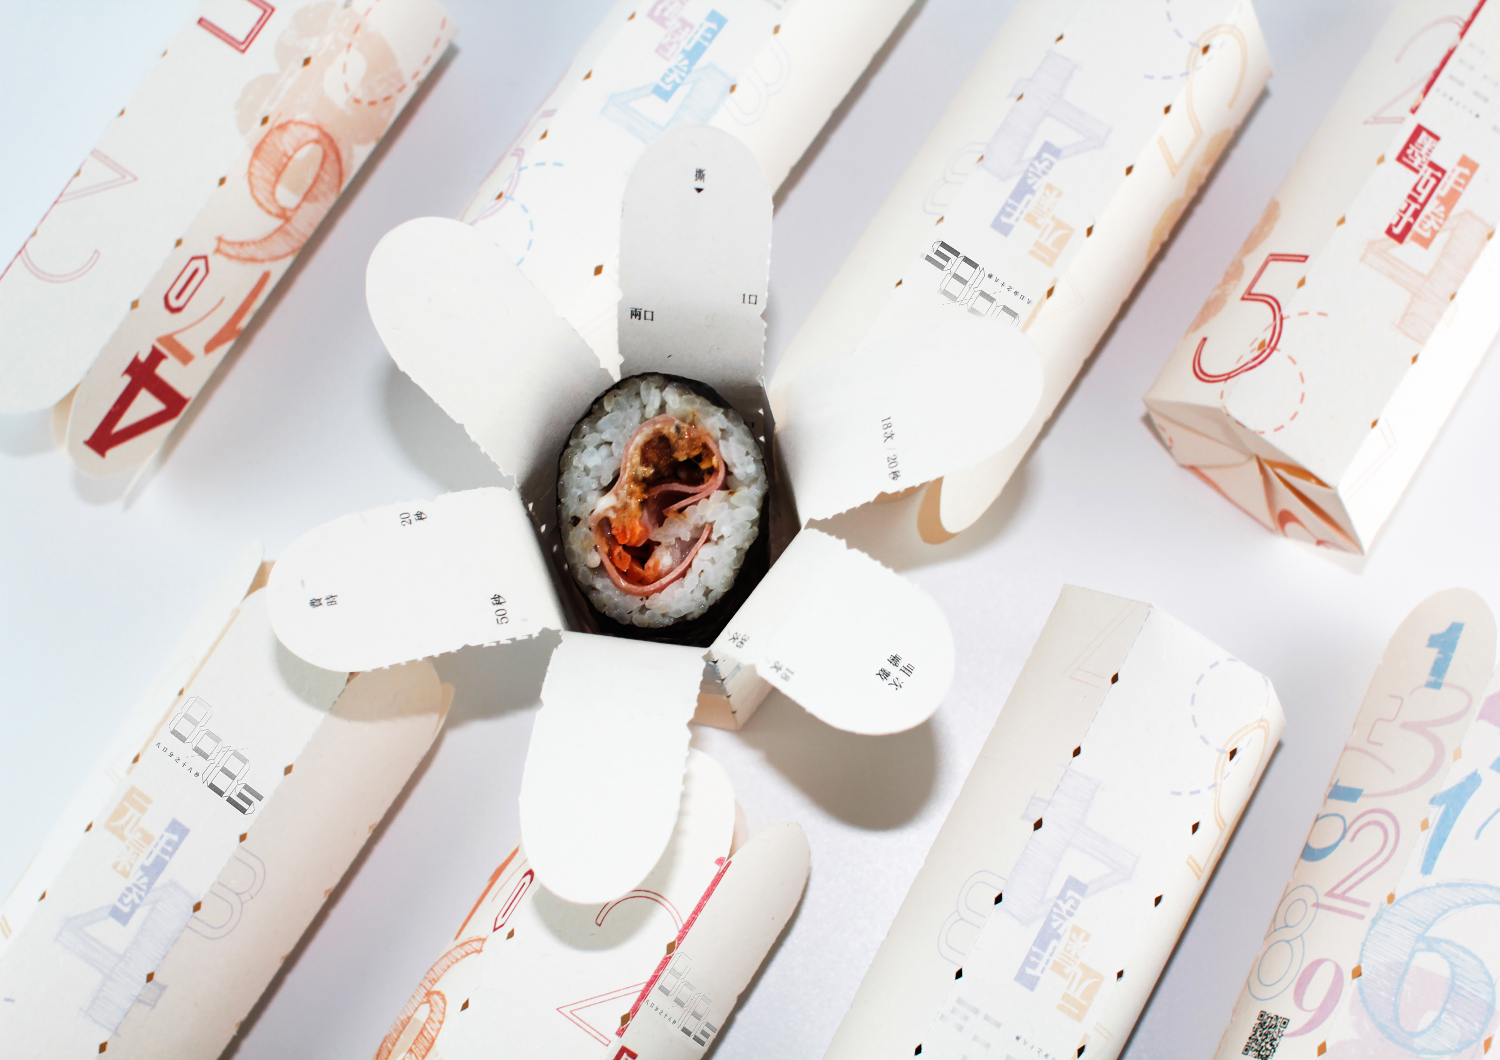

8口分之18秒

組員: 蕭雨濛 / 鄭心怡

Behance: <https://www.behance.net/gallery/78996773/8-Sip-18-Seconds>

眼睛: IMG_2387_0000_圖層-1.png

現代人在超商選擇即食食品的比例高，為了節省時間，食品包裝通常方便開啟，進而養成了消費者狼吞虎嚥的飲食習慣。為解決現代人飲食不規律的問題，本作品運用包裝裂線的撕與折來開啟產品。容器上特殊的孔洞設計，促使食物停在一口的份量。包裝內側呈現每種食物應分成幾口食用、咀嚼次數、費時多久等飲食資訊。讓消費者能有效率且健康的食用速食，提醒現代人要樂活享食。

Many modern people often buy instant foods in convenience stores. To save time, food packaging is easy to open, which makes consumers from the habit of eating fast. In order to solve the problem of irregular diet of people, this work uses tearing and folding of the packaging line to open the product. The special hole design on the container can keep food in a single bite. Inside of the package shows detailed directions on how many times to chew and how long it takes. It makes consumers eat fast food efficiently and healthily, reminding modern people to eat happily.

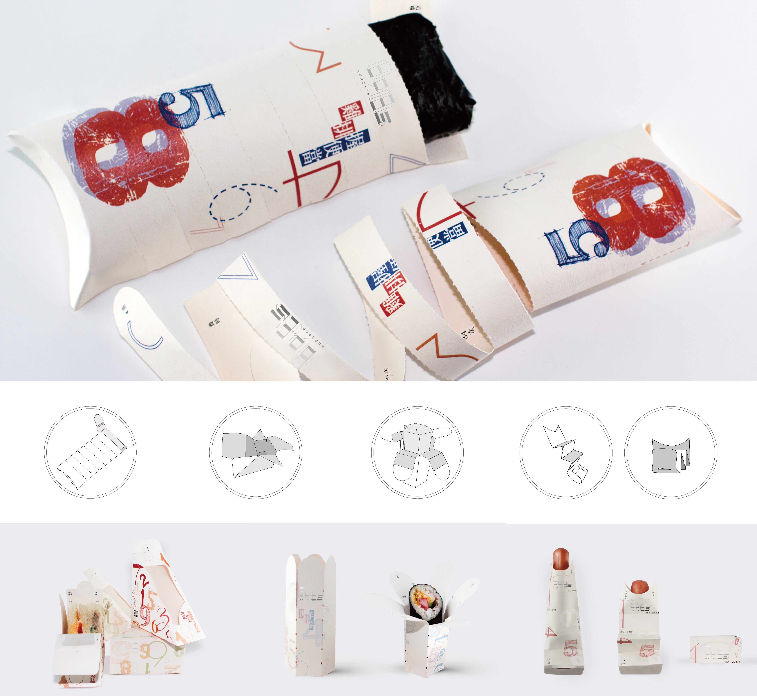

**大圖**

主題概念將食品包裝設計平均分為8口食用，每口花費18秒咀嚼，故命名為8口分之18秒，傳達本專題之理念。

本商品包裝設計作品之研究在於顛覆以往的速食包裝結果，以反便利性為出發點，提倡國民健康有效率的飲食。藉由現有包裝設計進行改良，利用裂線和特殊孔洞的設計，開啟食物包裝時，能停在一口的份量，包裝內側呈現商品資訊，使產品使用者能細嚼慢嚥，用最有效率及健康的咀嚼次數和時間來食用。



(影片連結: <https://youtu.be/lgHaCoXWvhA>)

握便當包裝設計 - 扁平式的包裝，在撕裂線時會在左側停下一口的量。

Hand-pressed bento Packaging - The flat packaging make it stop at the left side when the line is tear.

手卷、三明治包裝設計 - 以撕的方式開啟食品．包裝上設計特殊孔洞，撕的時候能剛好停在一口的份量。

Hand roll / Sandwich Packaging - Using tear of the packaging line to open the product.The special hole design on the container can keep food in a single bite.

熱狗袋包裝設計 - 以折的概念，紙袋沿著設計好的折痕，折一次為一口的量。

Hot dog paper bag - Using fold of the packaging line to eat. Fold it once in a single bite.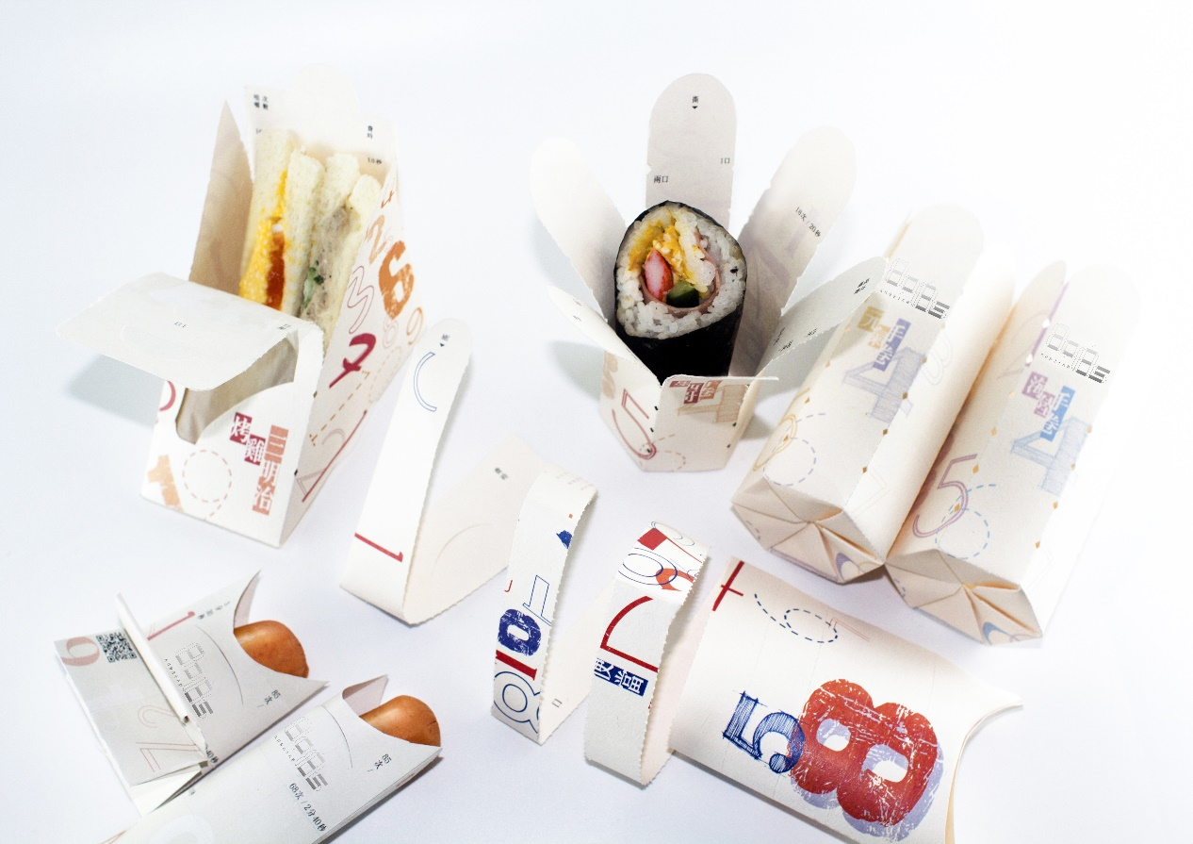

**(大圖)**